- SELECT name, surname, groups FROM student ORDER BY groups, surname;
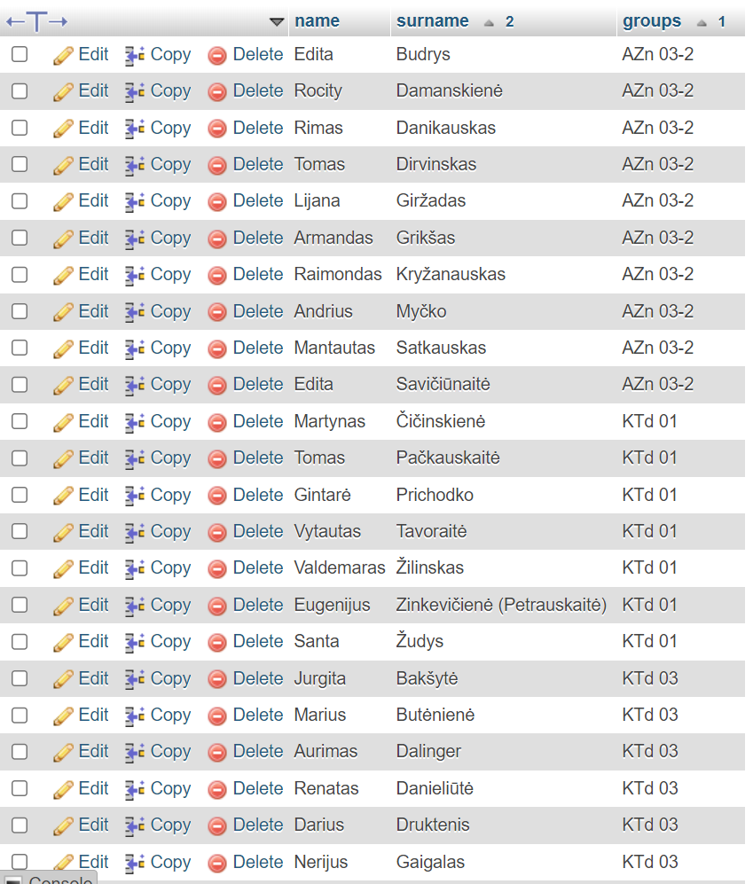
- SELECT count(id) FROM student;
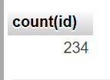
- SELECT count(gen) FROM student GROUP BY gen;
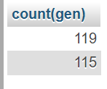
- SELECT count(id) FROM student WHERE status='Active' AND city LIKE '%city';
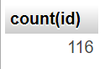
- SELECT DISTINCT groups FROM student ORDER BY groups DESC;
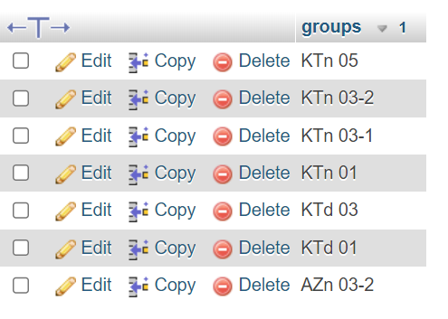
- SELECT name, surname, birthday FROM student WHERE birthday BETWEEN '1988-09-01' AND '1989-08-31';
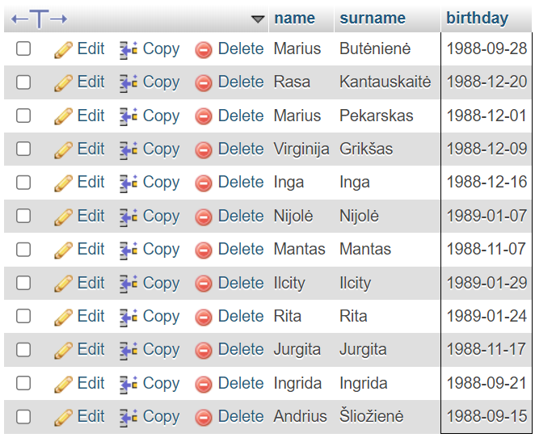

- SELECT name, surname, (YEAR(NOW()) - YEAR(birthday)) AS current_age FROM student ORDER BY 3 DESC LIMIT 20; 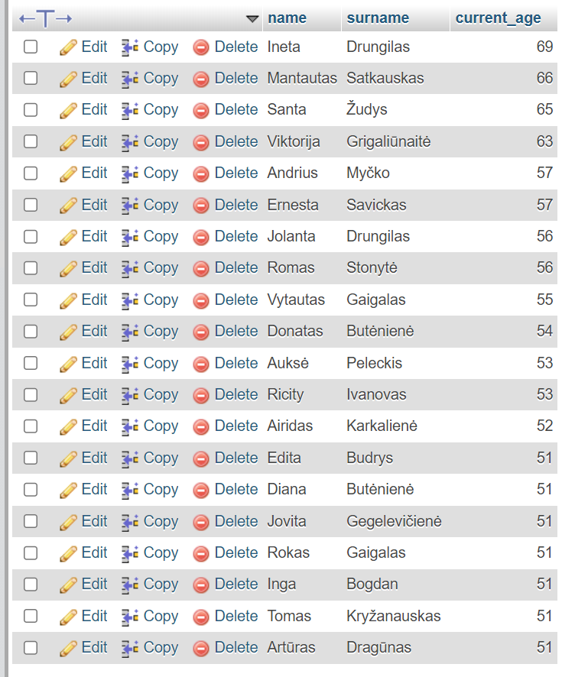
- SELECT city, COUNT(*) AS students FROM student GROUP BY city;
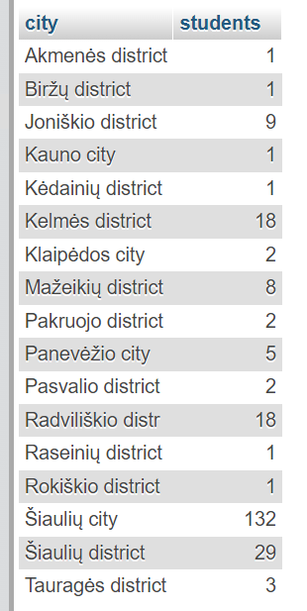

- SELECT groups, COUNT(*) AS students FROM student GROUP BY groups;
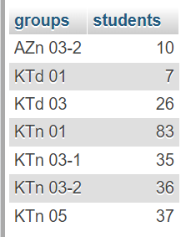
- SELECT status, COUNT(*) AS student_count FROM student GROUP BY status ORDER BY
student_count DESC LIMIT 1;
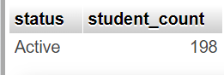
SELECT status, COUNT(*) AS student_count FROM student GROUP BY status ORDER BY
student_count ASC LIMIT 1;
